OOPS LAB FILE

BY: AMAN TYAGI
R171218017

EXPERIMENT -6
TITLE: Package

1)Write a Java program to implement the concept of importing classes from user defined package and created packages.

Code:

package pckg1;

public class Exp6_1 {
public int add(int a, int b){
return a+b;
}
public static void main(String args[]){
Exp6_1 obj = new Exp6_1 ();
System.out.println(obj.add(100, 100));
}
}

import pckg1.Exp6_1;
public class Exp_6_1a{
public static void main(String args[]){
Exp6_1 obj = new Exp6_1 ();
System.out.println(obj.add(200, 200));
}
}

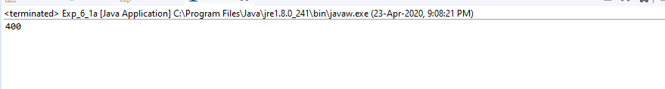

2) Write a program to make a package Balance. This has an Account class with Display_Balance method. Import Balance package in another program to access Display_Balance method of Account class.

Code:
package balance;
import java.io.*;
public class Exp6_2
{
public static void main(String ar[])
{
try
{
balance.Account a=new balance.Account();
a.read();
a.dispbal();
}
catch(Exception e)
{ System.out.println(e); }
}
}
class Account
{
long acc,bal;
String name;
public void read()throws Exception
{
DataInputStream in=new DataInputStream(System.in);
System.out.println("Enter the name :");
name=in.readLine();
System.out.println("Enter the account number :");
acc=Long.parseLong(in.readLine());
System.out.println("Enter the account balance :");
bal=Long.parseLong(in.readLine());
}
public void dispbal()
{
System.out.println(" Account Details ");System.out.println("Name :"+name);
System.out.println("Account number :"+acc);
System.out.println("Balance :"+bal);
}
}

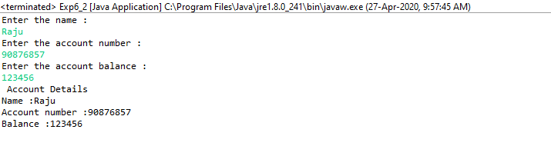

EXPERIMENT -7
TITLE: Exceptions

1)Write a program in Java to display the names and roll numbers of students. Initialize respective array variables for 10 students. Handle ArrayIndexOutOfBoundsExeption, so that any such problem doesn’t cause illegal termination of program.

Code:
import java.io.*;
class student
{
String name,grade; int reg,m1,m2,m3;
void read()throws Exception
{
DataInputStream in= new DataInputStream(System.in); System.out.println("enter the sapid : "); reg=Integer.parseInt(in.readLine()); System.out.println("enter the name : "); name=in.readLine();
System.out.println("enter mark1 : ");

m1=Integer.parseInt(in.readLine()); System.out.println("enter mark2 : "); m2=Integer.parseInt(in.readLine()); System.out.println("enter mark3 : "); m3=Integer.parseInt(in.readLine());
}
public void disp_grade()
{
int tt=m1+m2+m3; if(tt>=250) grade="A";
else if(tt>=200) grade="B"; else if(tt>=150) grade="C"; else if(tt>=100) grade="D"; else grade="E";
System.out.println("Grade :"+grade);
}
void disp()
{
System.out.println(" MARK LIST OF STUDENTS "); System.out.println("Sap Id :"+reg); System.out.println("Name :"+name); System.out.println("Mark1 :"+m1);
System.out.println("Mark2 :"+m2); System.out.println("Mark3 :"+m3); disp_grade();
}
}
class Exp7_1
{
public static void main(String ar[])
{
int no=0;
student s=new student(); try
{
DataInputStream in= new DataInputStream(System.in); System.out.println("enter the number of students : "); no=Integer.parseInt(in.readLine());
for(int i=0;i<no;i++); s.read();
}
catch(ArrayIndexOutOfBoundsException e)
{
System.out.println("the maximum students should be ten\n"); no=10;
}
catch(Exception e)
{ System.out.println(e); } for(int i=0;i<no;i++);
s.disp();
}
}

OUTPUT:
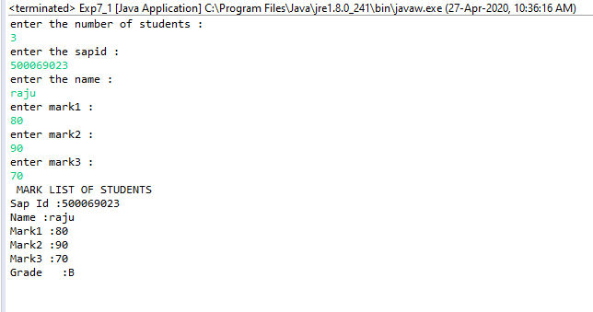

2) Write a Java program to enable the user to handle any chance of divide by zero exception.

Code:
import java.util.*;
class Exp7_2
{
private static Scanner in;

public static void main(String args[])
{
int a,b;
float r;
System.out.println("Enter the numerator:");
in = new Scanner(System.in);
b=in.nextInt();
System.out.println("Enter the denominator:");
a=in.nextInt();
try
{
if(a==0)
{System.out.println("Program Terminated");
throw new Exception();
}
if(a!=0)
{
r=b/a;
System.out.println("Answer:"+r);
}
}
catch(Exception e)
{
System.out.println("Exception :Cannot be Divide By Zero");
}
}
}

OUTPUT:

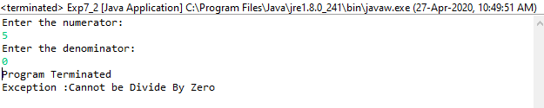
3) On a single track two vehicles are running. As vehicles are going in same direction there is no problem. If the vehicles are running in different direction there is a chance of collision. To avoid collisions write a Java program using exception handling. You are free to make necessary assumptions.

Code:
import java.util.*;
class collision extends Exception
{
collision(String s)
{ super(s); }
}
class Exp7_4
{
public static void main(String ar[])
{
String car1=null,car2=null;
try
{
Scanner sc= new Scanner(System.in);
System.out.println("Enter direction of car1(left/right):");
car1= sc.nextLine();
System.out.println("Enter the direction of car2(left/right):");
car2= sc.nextLine();
if(!car1.equals(car2))
throw new collision("car2 has to go on "+ car1 +" direction");
}
catch(collision e)
{
System.out.println(e);
car2=car1;
System.out.println("Changed the direction of car2");
}
}}

Output:

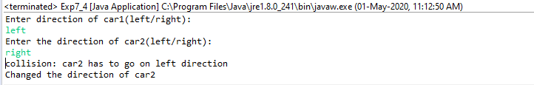

4)Write a java program to throw an exception for an employee details.
- If an employee name is a number, a name exception must be thrown.
- If an employee age is greater than 50, an age exception must be thrown.
Or else an object must be created for the entered employee details

Code:
import java.io.*;
import java.util.*;
class Numx
{
public static void main (String args[]){
{
String name;
int age;
System.out.println("Enter Name and Age:");
Scanner in=new Scanner(System.in);
try
{
if(!(in.nextLine().matches("[a-zA-Z]+")))
{throw new IOException();}

age=in.nextInt();
if(age>50)
{
System.out.println("Age greater 50 Exception found");
throw new Exception();
}
Numx x=new Numx();
System.out.println("Object Saved");
}
catch(Exception e)
{
System.out.println("Exception found");
}
}
}}

Output:

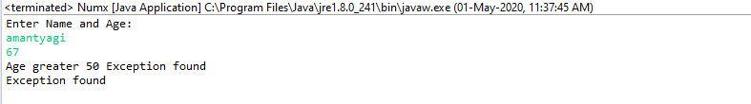

EXPERIMENT – 8
TITLE: Strings Handling and Wrapper Class

1)Write a program for searching strings for the first occurrence of a character or substring and for the last occurrence of a character or substring.

Code:
import java.util.*;
class Exp8_1
{
public static void main(String[]args) throws Exception
{
int length1,length2,last=0;
Scanner sc= new Scanner(System.in);
System.out.println("Enter the main string:");
String s1= sc.nextLine();
System.out.println("Enter the substring to be searched:");
String s2= sc.nextLine();
length1=s1.length();
length2=s2.length();
for(int i=0;i<=(length1-length2);i++)
{
if(s1.substring(i,length2+i).equals(s2))
{
if(last==0)
System.out.println("First occurance of substring is at :"+(i+1)); last=i+1;
}
}
if(last!=0)
System.out.println("Last occurance of substring is at :"+last);
else
System.out.println("The substring is not found.");
}
}

Output:
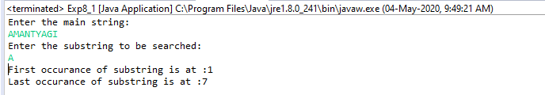

2)Write a program that converts all characters of a string in capital letters. (Use StringBuffer to store a string). Don’t use inbuilt function.

Code:
import java.util.*;
public class Exp8_2
{
public static void main (String []args)
{
String res="";
Scanner sc= new Scanner(System.in);
System.out.println("Enter a String in lowercase: ");
String str= sc.nextLine();
int a = str.length();
str=str.toUpperCase();
StringBuffer s1= new StringBuffer();
for(int x=0;x<a;x++)
{
s1.append(""+str.charAt(x));
}
res=s1.toString();
System.out.println("String in UPPER CASE: "+res);
}
}

Output:

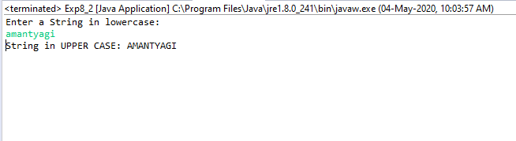

3)Write a program in Java to read a statement from console, convert it into upper case and again print on console. (Don’t use inbuilt function)

Code:
import java.io.*;
import java.util.Scanner;
class Exp8_3
{
public static void main(String a[]) throws IOException
{
Scanner sc= new Scanner(System.in);
System.out.println("Enter Statement to convert to uppercase:");
String string1= sc.nextLine();
System.out.println("Statement converted to uppercase: "+string1.toUpperCase());
}
}

Output:
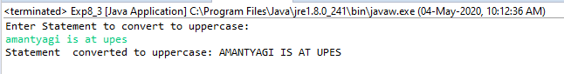
4)Write a program in Java to create a String object. Initialize this object with your name. Find the length of your name using the appropriate String method. Find whether the character ‘a’ is in your name or not; if yes find the number of times ‘a’ appears in your name. Print locations of occurrences of ‘a’ .Try the same for different String objects

Code:
class Exp8_4
{
String name;
Exp8_4(String n)
{
name=n;
}
void disp()
{
System.out.println("Name :"+name);
int c=0;
int len=name.length();
for(int i=0;i<len;i++)
if(name.charAt(i)=='A'||name.charAt(i)=='a')
{
c++;
System.out.println("Number of occurance of a :"+c);
System.out.println("Possition of a :"+(i+1));
}
if(c==0)
System.out.println("There is no occurence of 'a'");
}
}
class Exp8
{
public static void main(String ar[])
{
Exp8_4 d1=new Exp8_4("Aman Tyagi");
d1.disp();
Exp8_4 d2=new Exp8_4("Devops");
d2.disp();
}
}

Output:

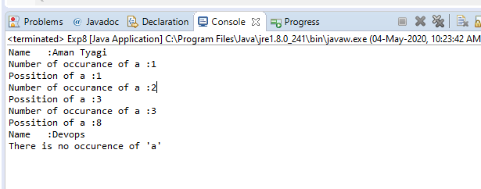
5)Write a Java code that converts int to Integer, converts Integer to String, converts String to int, converts int to String, converts String to Integer converts Integer to int.

Code:
public class Exp8_5 {
public static void main(String[] args)
{
int a = 30;
Integer j = a;
System.out.println("Int to Integer:"+j);
Integer a2 = new Integer(10);
String a3 = Integer.toString(a2);
System.out.println(a3);
String str2 = "100";
Integer j2= Integer.parseInt(str2);
System.out.println("String to int:"+j2);
int j3 = 100;
System.out.println("int to String:"+j3);
String str = "100000";
Integer obj2 = Integer.valueOf(str);
System.out.println("String to Integer:" +obj2);
Integer a1 = new Integer(3);
int j1 = a1;
System.out.println(j1);
}
}

Output:
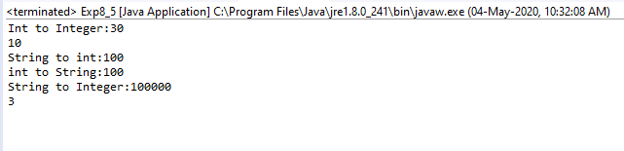

6)Write a Java code that converts float to Float converts Float to String converts String to float converts float to String converts String to Float converts Float to float.

Code:
public class Exp8_6 {
public static void main(String[] args)
{
float f = 100.00f;
float f1 = new Float(f);
System.out.println("Float to Float conversion :"+f1);
Float fObj = new Float(9.7);
String str = fObj.toString();
System.out.println(str);
String str4 = "10000.00";
Float f3 = Float.parseFloat(str4);
System.out.println("String to Float conversion:"+f3);
Float f6 = 12.00f;
System.out.println("Float to String conversion :"+f6);
String str2 = "92.00";
float f7 = Float.parseFloat(str2);
System.out.println("String to Float conversion "+f7);
}
}

Output:
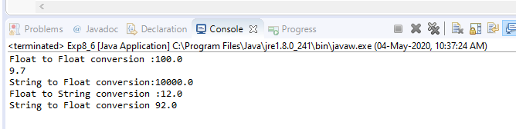

EXPERIMENT-9
TITLE: Threads and Collections

1)Write a program to implement the concept of threading by extending Thread Class and Runnable interface.

Code:
class ImplementsRunnable implements Runnable {
private int counter = 0;
public void run() {
counter++;
System.out.println("ImplementsRunnable : Counter : " + counter);
}
}
class ExtendsThread extends Thread {
private int counter = 0;
public void run() {
counter++;
System.out.println("ExtendsThread : Counter : " + counter);
}
}
public class Thread_exp1 {
public static void main(String args[]) throws Exception {
ImplementsRunnable rc = new ImplementsRunnable();
Thread t1 = new Thread(rc);
t1.start();
Thread.sleep(1000);
Thread t2 = new Thread(rc);
t2.start();
Thread.sleep(1000);
Thread t3 = new Thread(rc);
t3.start();
ExtendsThread tc1 = new ExtendsThread();
tc1.start();
Thread.sleep(1000);
ExtendsThread tc2 = new ExtendsThread();
tc2.start();
Thread.sleep(1000);
ExtendsThread tc3 = new ExtendsThread();
tc3.start();
}
}

Output:

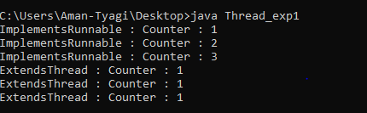

2)Write a program for generating 2 threads, one for printing even numbers and the other for printing odd numbers.

Code:
class even extends Thread
{
Thread t=null;
even()
{
t=new Thread(this);
start();
}
public void run()
{
try
{
for(int i=2;i<10;i+=2)
System.out.print(i+"\n");
Thread.sleep(100);
}

catch(Exception e)
{
System.out.println("thread interepted");
}
}

class odd extends Thread

Thread t=null;
odd()
{
t=new Thread(this);
start();
}
public void run()
{
try
{
for(int i=1;i<10;i+=2)
System.out.print(i+"\n" );
Thread.sleep(100);
}
catch(Exception e)
{
System.out.println("thread interepted");
}
}

public lass Thread_exp2
{
public static void main(String args[])
{
even e=new even();
odd o=new odd();
}
Output:
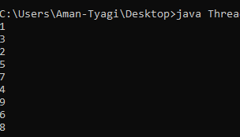

3)Write a program to launch 10 threads. Each thread increments a counter variable. Run the program with synchronization.

Code:
public class Thread_exp3
{
public static void main(String arg[])throws Exception
{
data d1=new data();
data d2=new data();
data d3=new data();
data d4=new data();
data d5=new data();
data d6=new data();
data d7=new data();
data d8=new data();
data d9=new data();
data d10=new data();
System.out.println(d10.count);
}
}
class item { static int count=0; }
class data extends item implements Runnable
{
item d=this;
Thread t;
data()
{
t=new Thread(this);
t.start();
}
public void run()
{ d=syn.increment(d); }
}
class syn
{
synchronized static item increment(item i)
{
i.count++;
return(i);
}
}

Output:
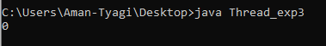

4)Write a Java program to create five threads with different priorities. Send two threads of the highest priority to sleep state. Check the aliveness of the threads and mark which thread is long lasting

Code:
public class Thread_exp4
{
public static void main(String args[]) throws InterruptedException
{
Thread T1=new Thread();
Thread T2=new Thread();
Thread T3=new Thread();
Thread T4=new Thread();
Thread T5=new Thread();
T1.setPriority(7);
T2.setPriority(2);
T3.setPriority(10);
T4.setPriority(5);
T5.setPriority(8);
T1.sleep(1500);
if (T1.isAlive())
System.out.println("Thread 1 is alive");
else
System.out.println("Thread 1 is not alive");
T2.start();
if (T2.isAlive())
System.out.println("Thread 2 is alive");
else
System.out.println("Thread 2 is not alive");
T3.sleep(1000);
if (T3.isAlive())
System.out.println("Thread 3 is alive");
else
System.out.println("Thread 3 is not alive");
T4.start();
if (T4.isAlive())
System.out.println("Thread 4 is alive");
else
System.out.println("Thread 4 is not alive");
T5.start();
if (T5.isAlive())
System.out.println("Thread 5 is alive");
else
System.out.println("Thread 5 is not alive");
}
}

Output:
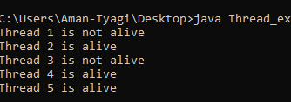

5)Write a program for the following:

Read all elements from ArrayList by using Iterator.
Create duplicate object of an ArrayList instance.
Reverse ArrayList content.
Code:
import java.util.ArrayList;
import java.util.Collections;
import java.util.Iterator;

public class Collection_exp
{
public static void main(String args[])
{
ArrayList<String> list = new ArrayList<String>();
list.add("Object");
list.add("Oriented");
list.add("Programming");
Iterator<String> itr = list.iterator();
while(itr.hasNext())
{
System.out.println(itr.next());
}
Collections.reverse(list);
System.out.println("After Reverse : ");
for(String str: list)
{
System.out.println(str);
}
System.out.println("Actual ArrayList:"+list);
ArrayList<String> copy = (ArrayList<String>) list.clone();
System.out.println("Duplicate ArrayList:"+copy);
}
}

Output:

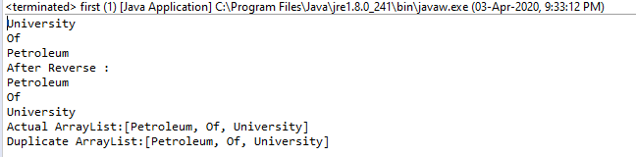
6)Write a program for the following HashMap

find whether specified key exists or not.
find whether specified value exists or not
get all keys from the given HashMap
get all key-value pair as Entry objects

Code:
import java.util.HashMap;
import java.util.Map.Entry;
import java.util.Set;

public class Collection_exp2
{
public static void main(String args[])
{
HashMap<String, String> hm = new HashMap<String, String>();
hm.put("1", "Object");
hm.put("2", "Oriented");
hm.put("3","Programming");
System.out.println(hm);

//finds whether specified key exists or not
if(hm.containsKey("1"))
{
System.out.println("The hashmap contains key 1");
}
else
{
System.out.println("The hashmap does not contains key 1");
}
if(hm.containsKey("4"))
{
System.out.println("The hashmap contains key 4");
}
else
{
System.out.println("The hashmap does not contains key 4");
}

if(hm.containsValue("Object"))
{
System.out.println("The hashmap contains value Object");
}
else
{
System.out.println("The hashmap does not contains value Object");
}
if(hm.containsValue("JAVA"))
{
System.out.println("The hashmap contains value JAVA");
}
else
{
System.out.println("The hashmap does not contains value JAVA");
}

Set<String> keys = hm.keySet();
for(String key: keys)
{
System.out.println(key);
}

Set<Entry<String, String>> entires = hm.entrySet();
for(Entry<String,String> ent:entires)
{
System.out.println(ent.getKey()+" ==> "+ent.getValue());
}
}
}

Output:
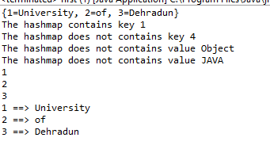

7)Write a program for the following HashSet

copy another collection object to HashSet object.
delete all entries at one call from HashSet
search user defined objects from HashSet

Code:
import java.util.HashSet;

public class Collection_exp3
{
public static void main(String args[])
{
HashSet<String> hs = new HashSet<String>();
hs.add("Object");
hs.add("Oriented");
hs.add("Programming");
System.out.println(hs);
HashSet<String> subSet = new HashSet<String>();
subSet.add("OOPS :");
hs.addAll(subSet);
System.out.println("HashSet content after copying ");
System.out.println(hs);
System.out.println("Clearing HashSet !!!");
hs.clear();
System.out.println("Content After clear - ");
System.out.println(hs);

}
}

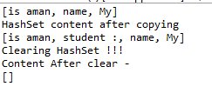

import java.util.HashSet;
import java.util.Objects;
import java.util.Set;

class Customer
{
private long id;
private String name;
public Customer(long id, String name)
{
this.id = id;
this.name = name;
}

public long getId()
{
return id;
}

public void setId(long id)
{
this.id = id;
}

public String getName()
{
return name;
}

public void setName(String name)
{
this.name = name;
}

// Two customers are equal if their IDs are equal
public boolean equals(Object obj)
{
if (this == obj)
return true;
if (obj == null || getClass() != obj.getClass())
return false;
Customer customer = (Customer) obj;
return id == customer.id;
}

@Override
public int hashCode()
{
return Objects.hash(id);
}

@Override
public String toString()
{
return "Customer{" + "id=" + id + ", name='" + name + '\'' + '}';
}
}

public class Collection_exp3_3
{
public static void main(String[] args)
{
Set<Customer> customers = new HashSet<>();
customers.add(new Customer(1, "Atishay"));
customers.add(new Customer(2, "ABC"));
customers.add(new Customer(3, "XYZ"));
for(Customer id:customers)
{
System.out.println(id);
}
Customer c = new Customer(1, "Atishay");
System.out.println(" Does this set contains key? " + customers.contains(c));

}
}
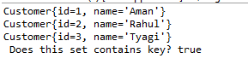

EXPERIMENT-10
TITLE: JDBC

1)Create a database table to store the records of employee in a company. Use getConnection function to connect the database. The statement object uses executeUpdate function to create a table.

Code:
import java.sql.*;
import javax.swing.JOptionPane;
public class Main {
public static void main(String[] args) {
try{
Class.forName("java.sql.Driver");
Connection con=(Connection)DriverManager.getConnection("jdbc:mysql://localhost:3306/exp10","root","");
Statement stmt=con.createStatement();
String query = "create table employee"+"" +
"(id integer," +
"name varchar(30))";
stmt.executeUpdate(query);
System.out.println("table created");
}
catch(Exception e)
{
JOptionPane.showMessageDialog(null ,e.getMessage());
}
}

}

Output:
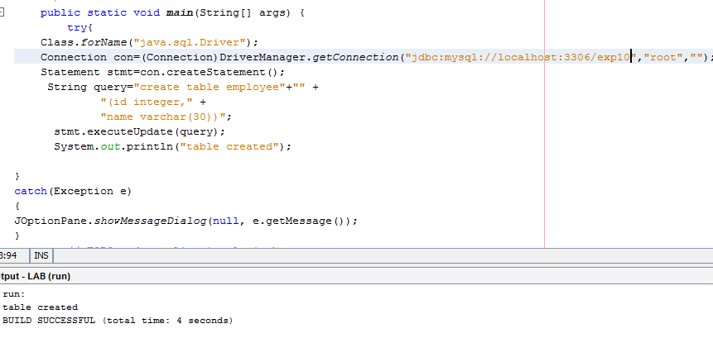

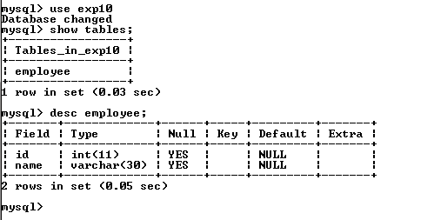

2)Create a database of employee of company in mysql and then use java program to access the database for inserting information of employees in database. The SQL statement can be used to view the details of the data of employees in the database.

Code:
import java.sql.*;
import javax.swing.JOptionPane;
import java.util.*;

public class Main {
public static void main(String[] args) { try{
Class.forName("java.sql.Driver");
Connection con=(Connection)DriverManager.getConnection("jdbc:mysql://localhost:3306/exp10","root","");
Statement stmt=con.createStatement();
stmt.executeUpdate("Insert into employee(id,name) values (1,'aman tyagi')");

System.out.println("Record updated");

}
catch(Exception e)
{System.out.println("Exception");
}

}

}

Output:
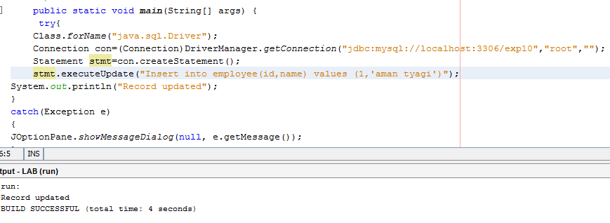

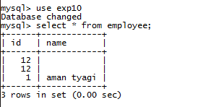

EXPERIMENT -11
TITLE: Servlet

1)Servlet: a) ServletContext interface b)getParameterValues( ) of Servlet Request

Code:
import java.io.IOException;
import java.io.PrintWriter;
import javax.servlet.ServletContext;
import javax.servlet.ServletException;
import javax.servlet.http.HttpServlet;
import javax.servlet.http.HttpServletRequest;
import javax.servlet.http.HttpServletResponse;
public class NewServlet extends HttpServlet {
protected void processRequest(HttpServletRequest req, HttpServletResponse res)throws IOException{
{
PrintWriter obj = res.getWriter();
String values[] = req.getParameterValues("num1");
int addition = 0;
for(int i =0;i<values.length;i++){
addition = addition + Integer.parseInt(values[i]);
}
obj.println("sum"+ addition);
obj.println("organization name");
ServletContext ctx= getServletContext();
String str = ctx.getInitParameter("name");
obj.println(str);
obj.println("Author name:");
String str1 = ctx.getInitParameter("author_name");
obj.println(str1);
}}

Output:

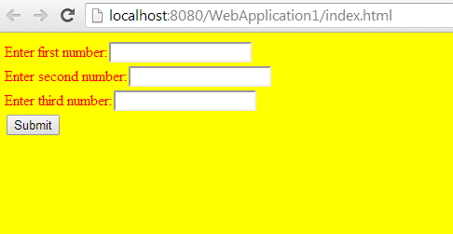

2)Write a Servlet page to display current date of the server

Code:
import java.io.*;
import java.util.*;
import javax.servlet.*;
import javax.servlet.http.*;

public class MyServlet extends HttpServlet{
public void doGet(HttpServletRequest request, HttpServletResponse
response) throws ServletException, IOException{
PrintWriter pw = response.getWriter();
Date today = new Date();
pw.println("<h1>Date is</h1>");
pw.println(today);
}
}

Output:
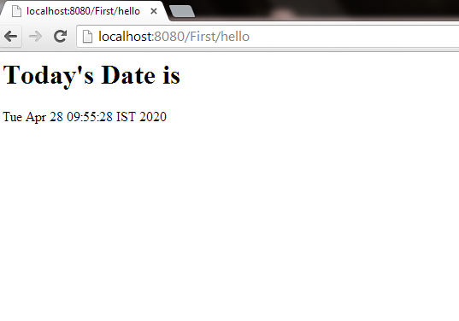

3)Write a Servlet page to which include the two other Servlet page through of include directives feature provided in Servlet.

Code:
<%@ include file = "first.jsp" %>
<center>
<p>Object oriented progamming question [Text from main file ]</p>
</center>
<%@ include file = "second.jsp" %>

Output:
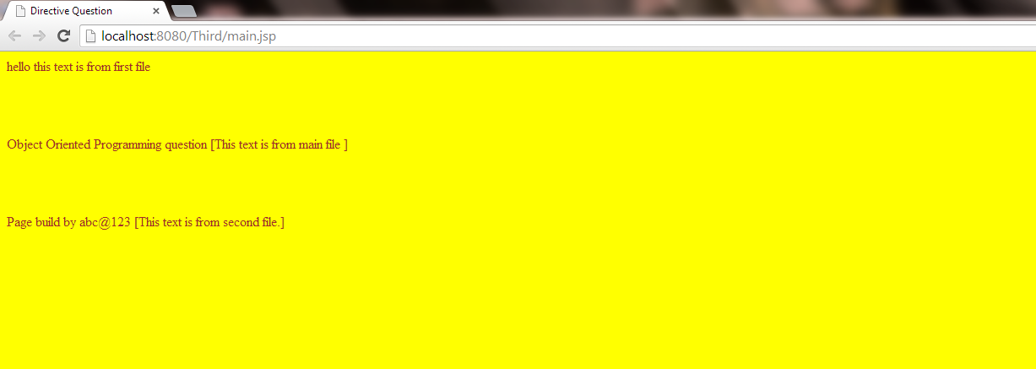

4)Write a Servlet page to create a simple calculator.

Code:

import java.io.IOException;
import java.io.PrintWriter;
import javax.servlet.ServletException;
import javax.servlet.http.HttpServlet;
import javax.servlet.http.HttpServletRequest;
import javax.servlet.http.HttpServletResponse;

public class MyServlet extends HttpServlet {

protected void doGet(HttpServletRequest request, HttpServletResponse response)
throws ServletException, IOException {

PrintWriter out = response.getWriter();
String n1 = request.getParameter("txt1");
String n2 = request.getParameter("txt2");
String op = request.getParameter("op");

if(op.equals("Addition")){
out.println((" ADDITION : " + ( Integer.parseInt(n1) + Integer.parseInt(n2))));
}
else if(op.equals("Subtraction")){
out.println(" SUBTRACTION : " + (Integer.parseInt(n1) - Integer.parseInt(n2)));
}
else if(op.equals("Multiplication")){
out.println(" MULTIPLICATION : " + (Integer.parseInt(n1) * Integer.parseInt(n2)));
}
else if(op.equals("Division")){
out.println(" DIVISION : " + (Integer.parseInt(n1) / Integer.parseInt(n2)));
}
else if(op.equals("Modulus")){
out.println(" MODULUS : " + (Integer.parseInt(n1) % Integer.parseInt(n2)));
}

}
}

Output:
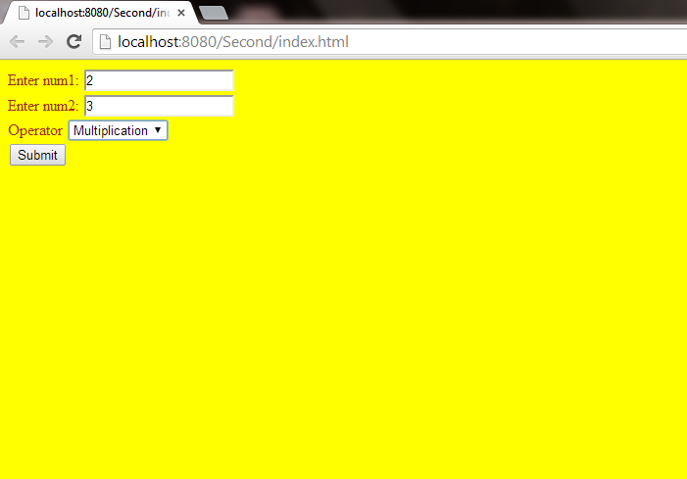
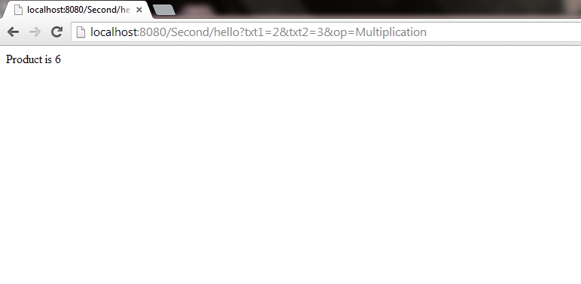

EXPERIMENT -12

Title: JSP

Objective: After these lab exercises students will be in position to clear the concept of JSP and how to write the server side scripting language.

Code:
To view data:

<%@ page import = "java.io.,java.util.,java.sql.*"%>
<%@ page import = "javax.servlet.http.,javax.servlet." %>
<%@ taglib uri="http://java.sun.com/jsp/jstl/core" prefix = "c"%>
<%@ taglib uri="http://java.sun.com/jsp/jstl/sql" prefix = "sql"%>

<html>
<head>
<title>Jsp</title>
</head>

<body>
<sql:setDataSource var = "snapshot" driver = "com.mysql.jdbc.Driver"
url = "jdbc:mysql://localhost:3306/school"
user = "root" password = ""/>

<sql:query dataSource = "${snapshot}" var = "result">
SELECT * from Student;
</sql:query>

<table border = "1" width = "100%">
<tr>
<th>Name</th>
<th>Sap Id</th>
<th>Course</th>
</tr>

<c:forEach var = "row" items = "${result.rows}">
<tr>
<td><c:out value = "${row.Name}"/></td>
<td><c:out value = "${row.Sap Id}"/></td>
<td><c:out value = "${row.Course}"/></td>
</tr>
</c:forEach>
</table>

</body>
</html>

To Update Data:

<%@ page import = "java.io.,java.util.,java.sql.*"%>
<%@ page import = "javax.servlet.http.,javax.servlet." %>
<%@ taglib uri="http://java.sun.com/jsp/jstl/core" prefix = "c"%>
<%@ taglib uri="http://java.sun.com/jsp/jstl/sql" prefix = "sql"%>

<html>
<head>
<title>Insert Operation JSP</title>
</head>

<body>
<sql:setDataSource var = "snapshot" driver = "com.mysql.jdbc.Driver"
url = "jdbc:mysql://localhost:3306/school"
user = "root" password = ""/>

<sql:update dataSource = "${snapshot}" var = "result">
UPDATE Student SET age = <%= request.getParameter("age")%>, name = '<%= request.getParameter("name")%>' WHERE id = <%= request.getParameter("id")%>;
</sql:update>

<sql:query dataSource = "${snapshot}" var = "result">
SELECT * from Student;
</sql:query>

<table border = "1" width = "100%">
<tr>
<th>Name</th>
<th>Sap Id</th>
<th>Course</th>
</tr>

<c:forEach var = "row" items = "${result.rows}">
<tr>
<td><c:out value = "${row.Name}"/></td>
<td><c:out value = "${row.Sap Id}"/></td>
<td><c:out value = "${row.Course}"/></td>
</tr>
</c:forEach>
</table>

</body>
</html>

To insert data:

<%@ tag import="java.io.*" %>
<%@ tag import = "javax.servlet.http.,javax.servlet." %>
<%@ taglib uri="http://java.sun.com/jsp/jstl/core" prefix = "c"%>
<%@ taglib uri="http://java.sun.com/jsp/jstl/sql" prefix = "sql"%>

<html>
<head>
<title>Insert Operation JSP</title>
</head>

<body>
<sql:setDataSource var = "snapshot" driver = "com.mysql.jdbc.Driver"
url = "jdbc:mysql://localhost:3306/school"
user = "root" password = ""/>

<sql:update dataSource = "${snapshot}" var = "result">
INSERT INTO Student VALUES (<%= request.getParameter("Name")%>, <%= request.getParameter("Sap Id")%>, '<%= request.getParameter("Course")%>' );
</sql:update>

<sql:query dataSource = "${snapshot}" var = "result">
SELECT * from Student;
</sql:query>

<table border = "1" width = "100%">
<tr>
<th>Name</th>
<th>Sap Id</th>
<th>Course</th>
</tr>

<c:forEach var = "row" items = "${result.rows}">
<tr>
<td><c:out value = "${row.id}"/></td>
<td><c:out value = "${row.name}"/></td>
<td><c:out value = "${row.age}"/></td>
</tr>
</c:forEach>
</table>

</body>
</html>

OUTPUT:
